Deal Rated

By

_________

Level-6

Final Project

Table of Contents

Project Proposal 3

Goals and Objectives 3

Project Scope 3

Project Specifications 3

Target Audience 3

Project Deliverables 4

Resource Requirements 4

Project Tasks and Milestones 4

Project Assumptions 5

Project Report 5

Detail Design 6

Home Page 6

Register Page 6

Login Page 7

Add Store Admin View 7

All Coupons Admin View 8

All Products Page View 8

Category Wise Store View 9

Store Deal Details View 9

Project Testing 10

User Manual 10

Summary 10

System Configuration 10

User Access Levels 10

# 

# Project Proposal

## Goals and Objectives

The main goal or aim of the project is to implement an online web application named “Deal Rated”. In today scenario, there are so many online shopping sites exists on internet. So, for an end user, it is good to purchase product with awesome discount so, they purchase more. This website provide comes in referral category in which it provides all deals of discounted coupon of different store. In this application there are two types of users- admin and registered visitor. Admin has different functionalities as compare to registered visitor. Admin has CMS capability to control the content of website. Registered user can access information related to coupon code.

## Project Scope

The scope of this project is to implement an app named “Deal Rated” with the help of which view the all deals of different store with their discounted coupon codes available on web site. The duration of the project is 20 working days which is equals to 4 weeks.

## Project Specifications

* Admin login/logout
* Add, edit, delete and check details of Store and Categories by admin.
* Admin can delete, edit and check Product Information available online.
* Admin can register new admins.
* Registered Visitor can login/logout.
* New Visitor can register.
* Registered Visitor capable to access store deals in form of coupon code.

## Target Audience

The target audience for this project is the people who want to save the time to search the coupon code to visit different site and this site provide a single place of different store coupon deals. The age can go from 18 plus to 100 plus.

## Project Deliverables

The deliverables of the project are:

|  |  |
| --- | --- |
| Deliverable | Description |
| Final Report | This will be the final report of the project. |
| Coding | The executable code of the project will go under this. |
| Documentation | This portrays the documentation of the project. |
| Testing | All the test details will be covered in this part. |

## Resource Requirements

* Windows Operating System.
* Microsoft word for documentation.
* Asp.net MVC Framework
* 64-bit Processor and 4 GB or more RAM
* Identity framework- ASP

## Project Tasks and Milestones

|  |  |  |  |  |
| --- | --- | --- | --- | --- |
| **Tasks** | **Week-1** | **Week-2** | **Week-3** | **Week-4** |
| Brainstorming and analysis |  |  |  |  |
| Planning and initial meeting Project Proposal document. |  |  |  |  |
| Database Design and UI Design |  |  |  |  |
| Identity framework implementation |  |  |  |  |
| Coding for admin and reporter |  |  |  |  |
| Testing |  |  |  |  |
| Final Documentation and closing |  |  |  |  |

## Project Assumptions

Following are the assumption made while implementing the project:

* One admin and registered visitor will be registered by default.
* Application will be free and open source.

# Project Report

#### Functional and Non-Functional

|  |  |
| --- | --- |
| Users | Functional |
| Admin | * Login/logout * Register new admins * Admin can add, edit, delete, check details for category, store, store deal in coupon. * Admin can edit, delete and check details for product information with their site link url. |
| Registered User | * Can view details of all products available at database * Can view details of all store with their logo. * Registered user capable to access the coupon code available for store deals * New customers can register for free. * Login using valid credentials |
|  | Non- Functional |
|  | * High speed * Fast Loading time * High performance and security * All browsers compatibility. |

## Detail Design

### Home Page

The main landing page of the application. On navigation bar options are- Home, Categories, Products, Register and Login. This displays all available store with link to show deals.

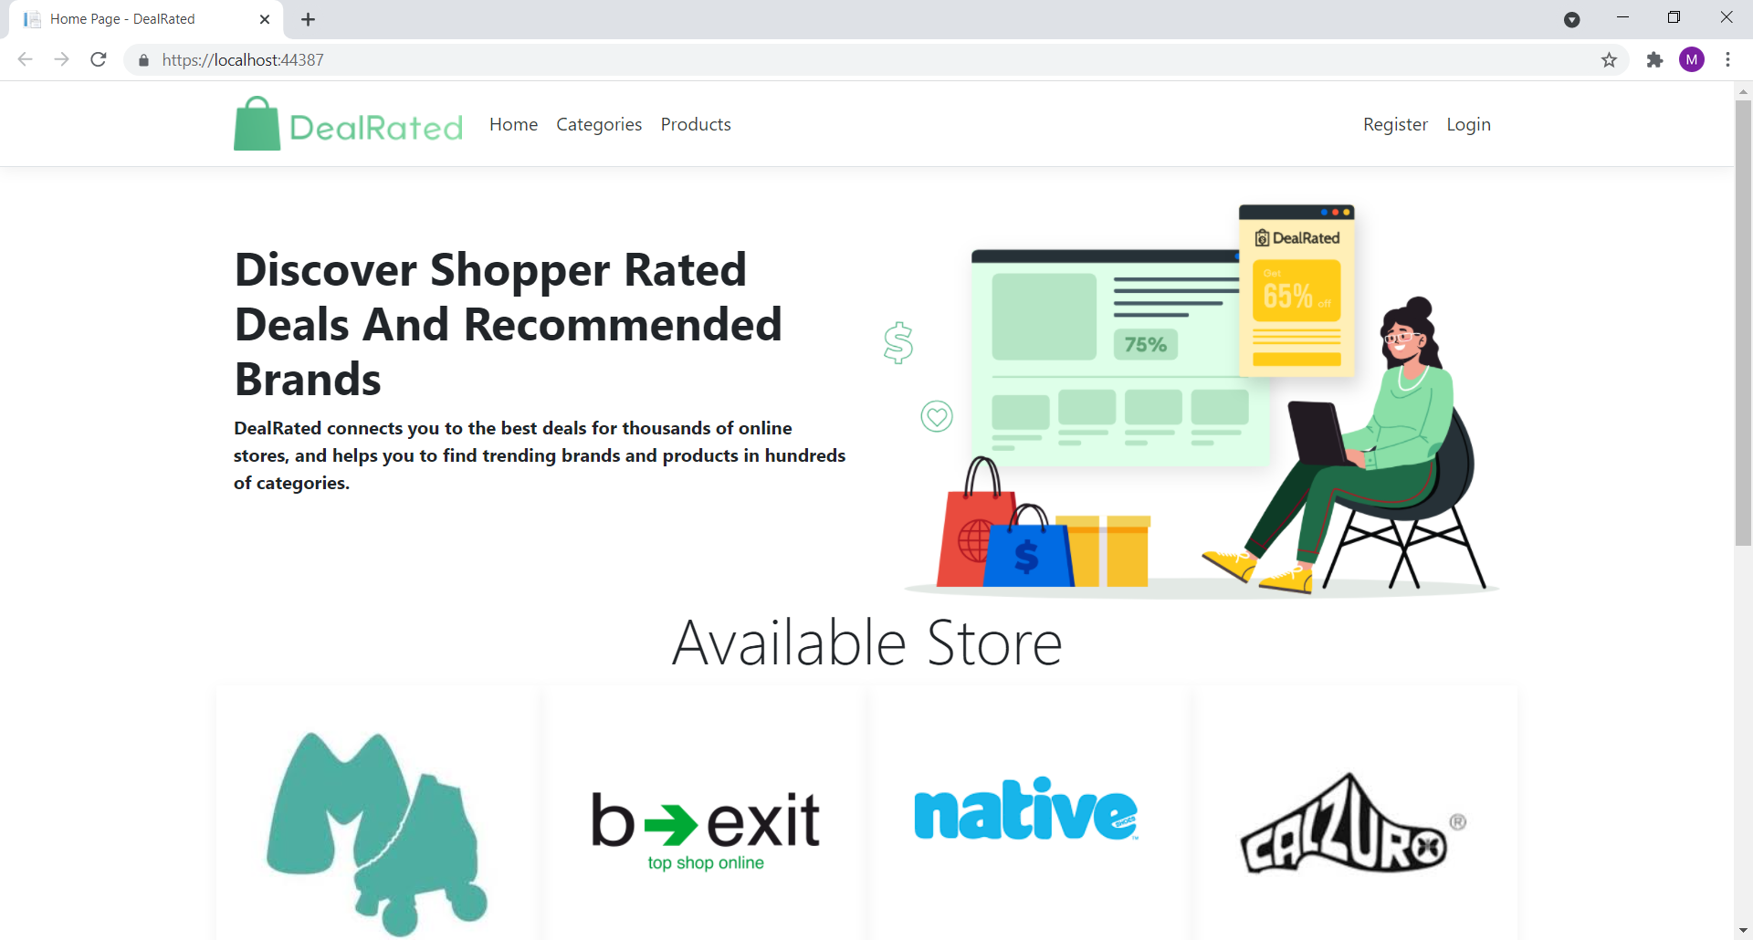

### Register Page

With the help of this page, new visitor can register online

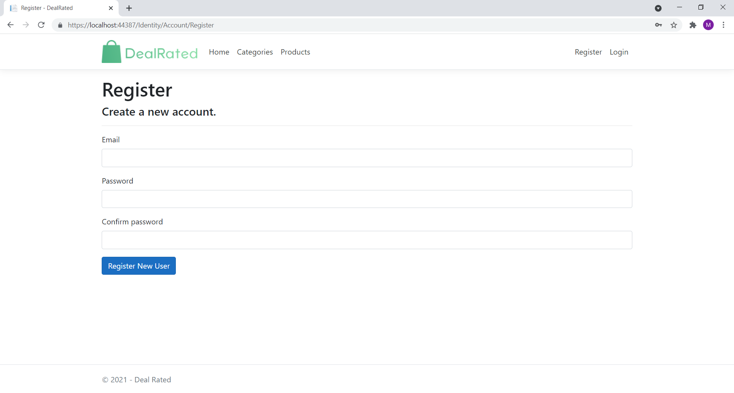

### Login Page

With the help of this page, visitor can login to page and access unrestricted page.

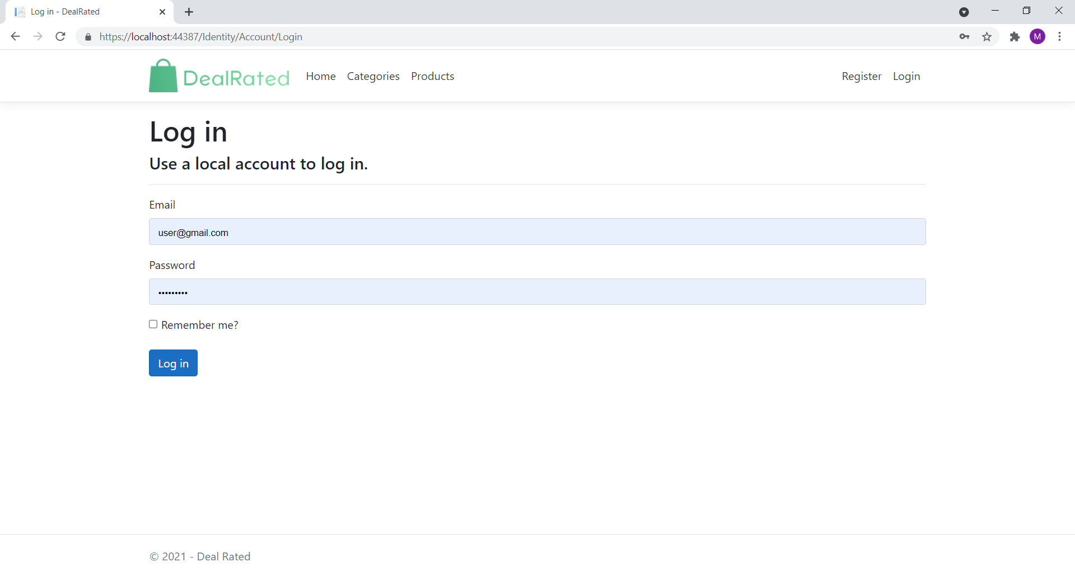

### Add Store Admin View

This page provides a way to add new Store Details with their logo.

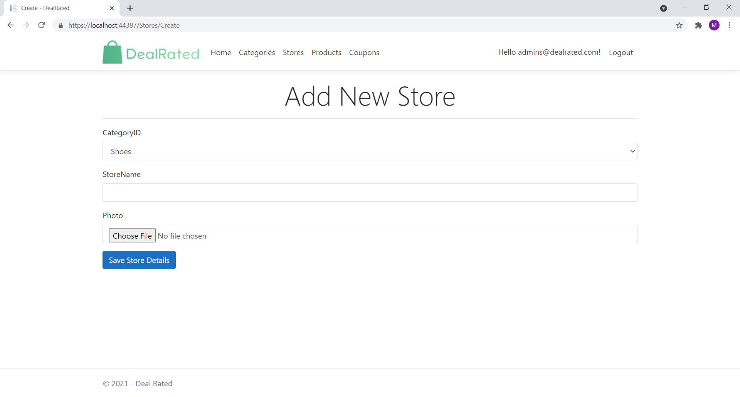

### 

### All Coupons Admin View

With the help of this page admin can view all store deals in form of coupon code.

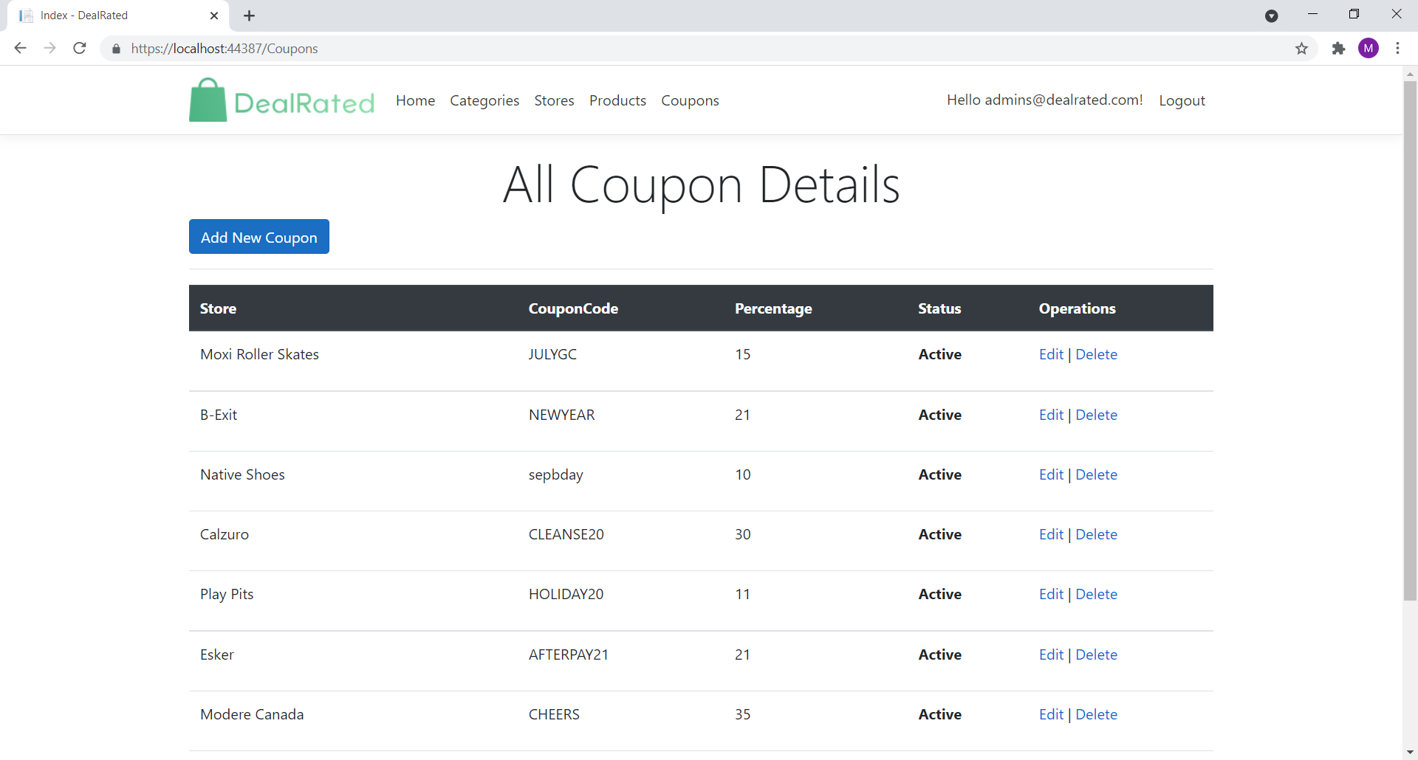

### All Product Page View

With the help of this page Visitor/Registered user can view all product original site url link.

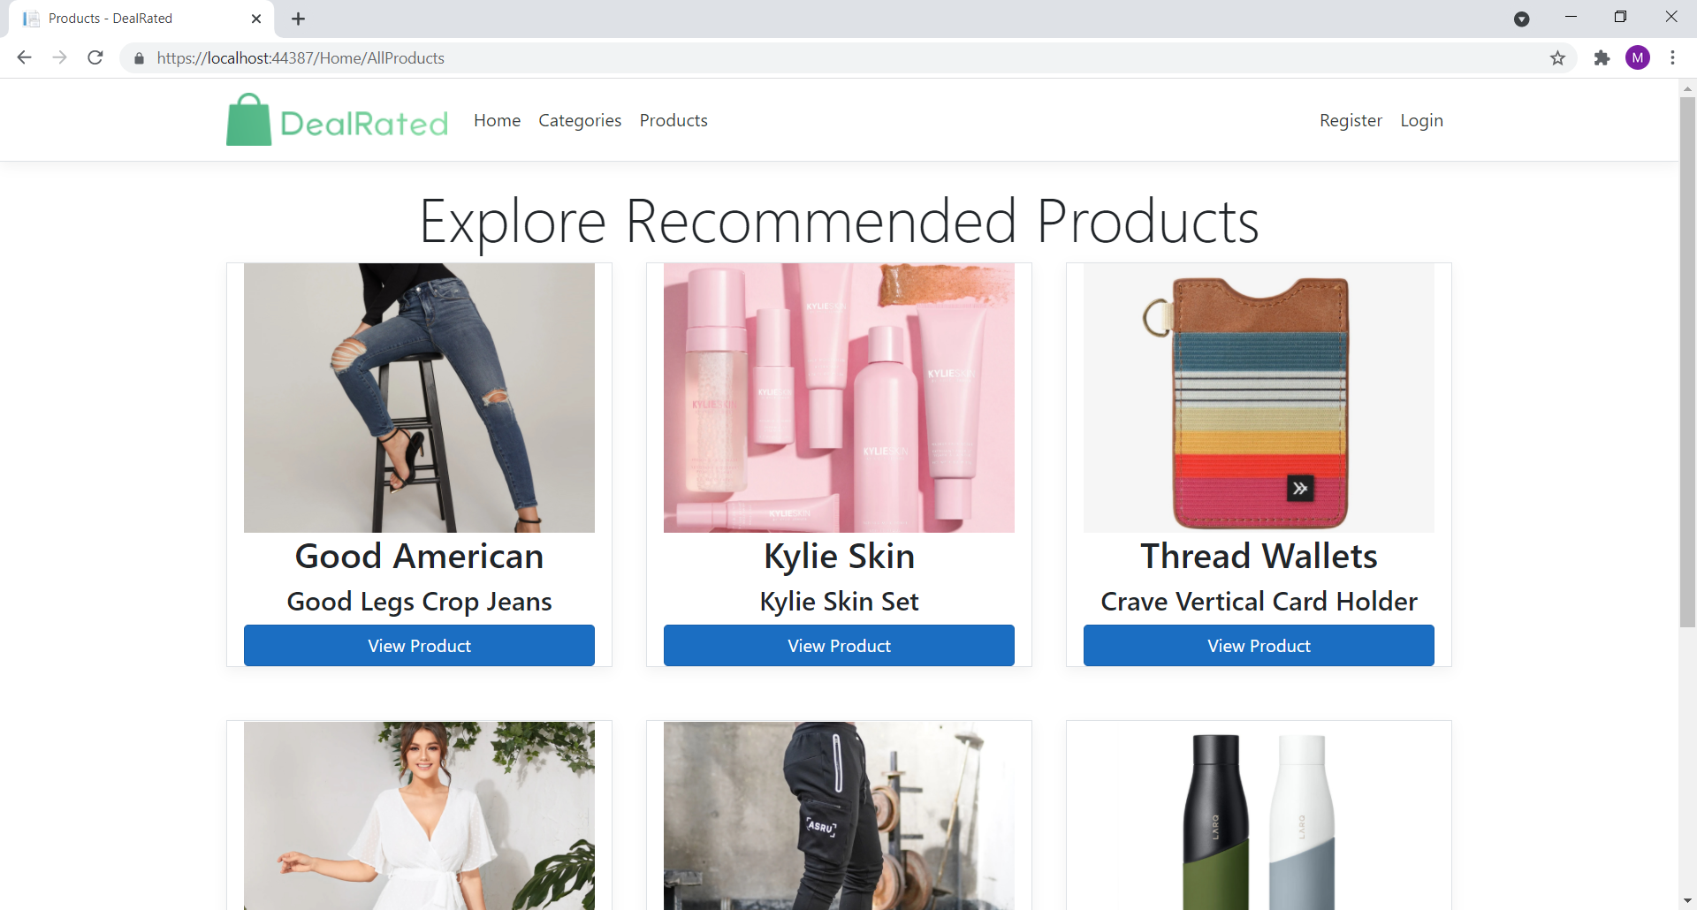

### Category Wise Store View

With the help of this page visitor can view all store of a category with their Deals link.

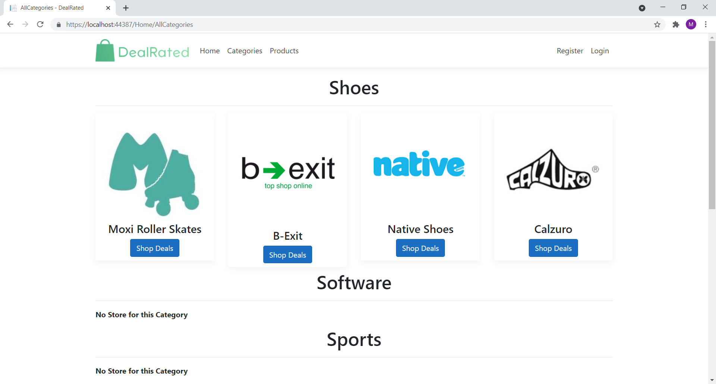

### Store Deal Details View

This page shows all Store Deal in form of coupon to registered users.

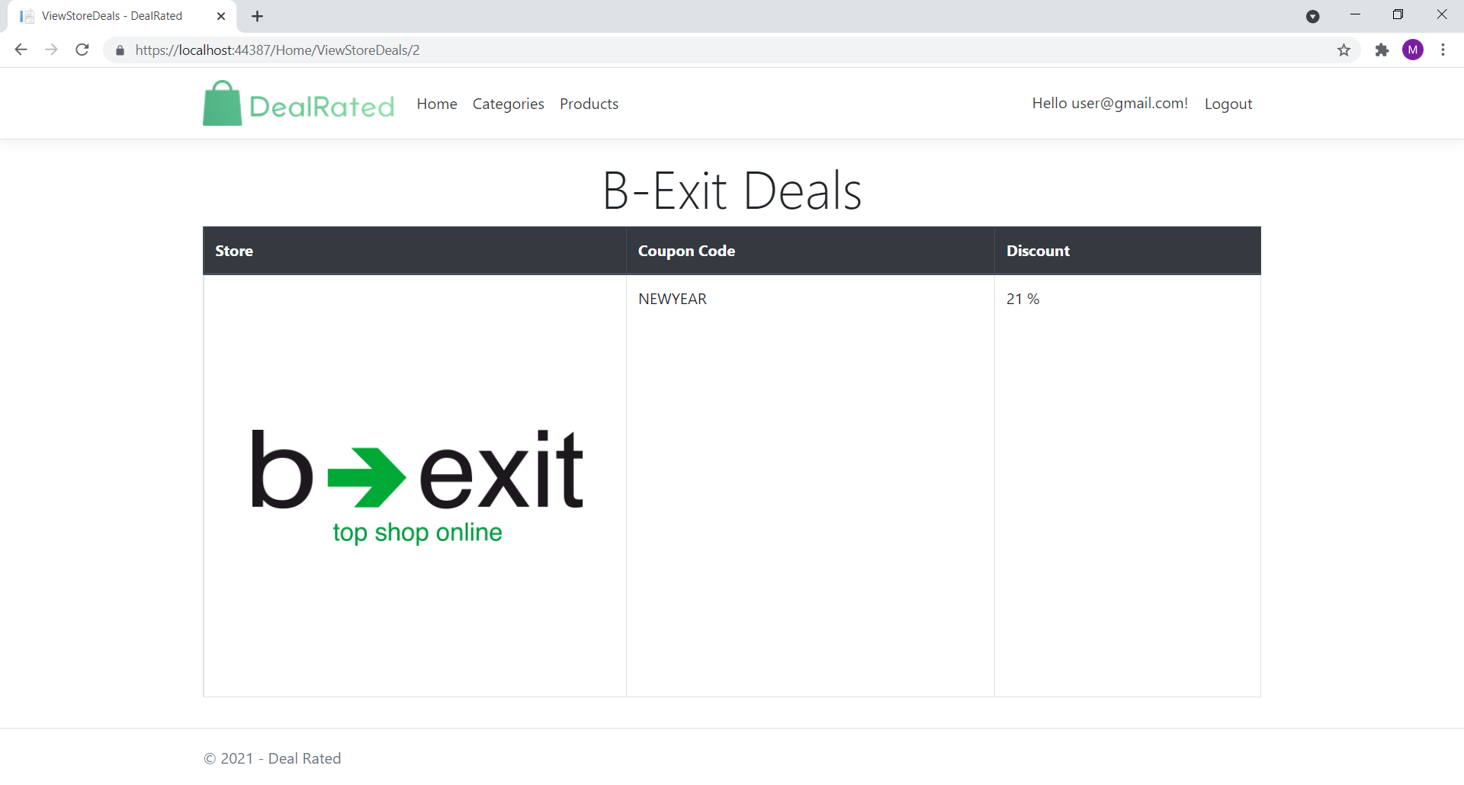

## Project Testing

The testing file for usability testing is attached as [usability test.xlsx](usability%20test.xlsx)

# User Manual

The main purpose of the application Deal Rated provides different deal available online at single place So, end user saves his/her time. In this application there are two types of users- admin and registered user or visitor. Admin has different functionalities as compare to registered user. Admin can control the information visible on web site. Registered User is capable to access details of coupon code of different store.

## Summary

### System Configuration

This app will be useful to for distributing mobile information in presentable format.

### User Access Levels

Only registered users can access the features of this application.

* **Admin:** Admin has full access of the app can register new admins.
* **Registered Visitor:** New visitor can register and existing can login using their own credentials. They have limited access.